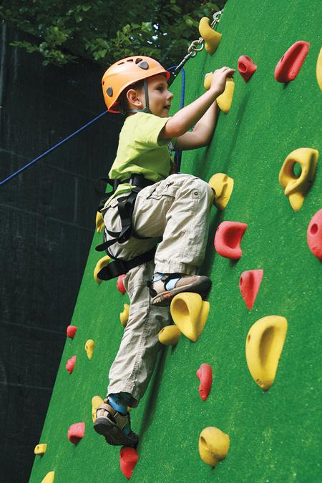

NO MEMBERSHIPS.

JUST FUN.

***Sit amet, ipsum erat lorem adipiscing eli, sed diam***

***dolore nibh euis mod erat***

***tinidunt ut laoreet erat***

***dolore magna aliquam.***

***5432 ANY STREET WEST***

***TOWNSVILLE, ST 54321***

(555) 543-5432

YOURWEBSITEHERE.COM

**ASK ABOUT OUR**

**BIRTHDAY PARTIES**

**OR HAVING**

**A PRIVATE EVENT!!!**

YOUR KIDS ARE

GOING TO GROW UP...

JUST NOT TODAY.

***Lorem ipsum dolo sit amet, ipsum erat lorem adipiscing eli, sed diam dolore nibh euis mod***

***erat tinidunt ut laoreet erat dolore magna***

***aliquam erat volutpat. Wisi enim minim veniam quis tera nostrud exerci ation ullamcorp.***